MACH4METAL

metalworking machinery
Transito 21,
6909 DA BABBERICH, Netherlands
Tel. + 31 (0)316 – 247123
Fax. + 31 (0)316 - 247956
info@mach4metal.com
www.mach4metal.com

Bank No : 66.52.13.883
IBAN : NL33 INGB 0665 2138 83
BIC : INGBNL2A

VTL DÖRRIES SDE 200

- Make : DÖRRIES Germany
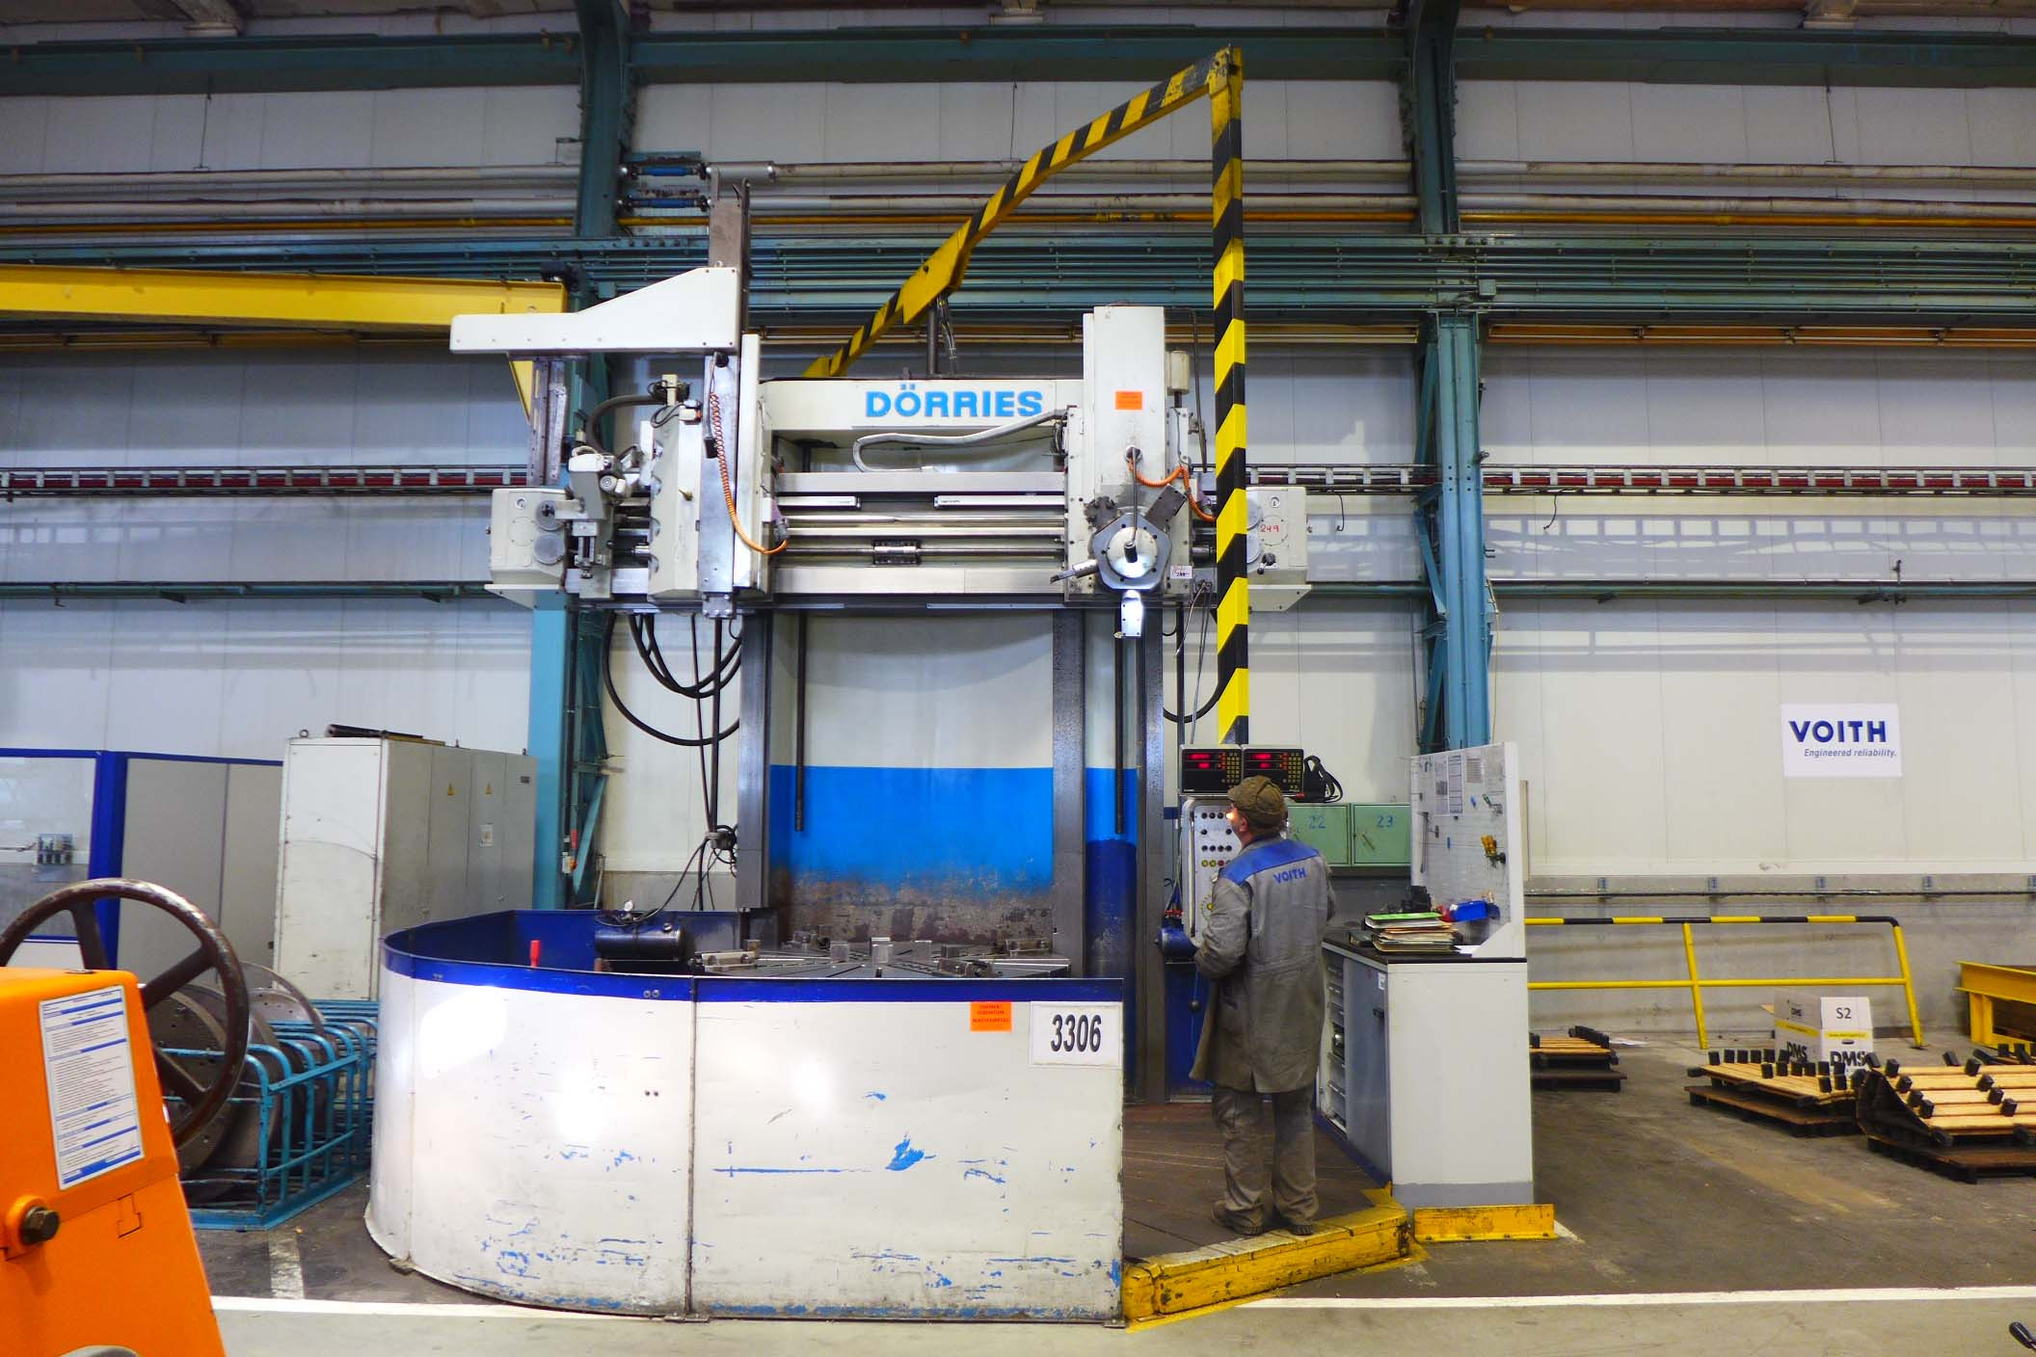
- Typ : SDE 200
- Age : 1974
- Serial.No : e 105 / 40 494

- Chuck Ø : 2.000
- Max swing Ø : 2.200

- Height under tool : 2.510
- Height under rail : 2.200
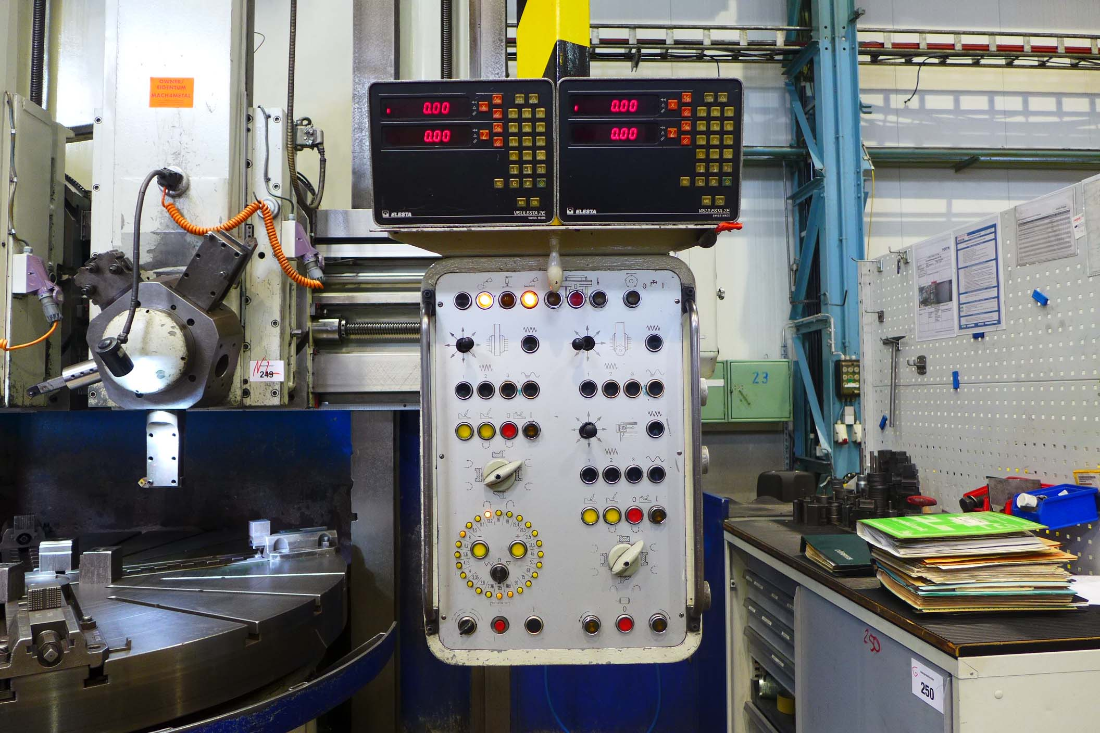
- Adjustment crossrail : 1.900

- Left Ram Hor + Vert : 1.300 / 1.030
- Right Ram Hor + Vert : 750 / 1.320
- Ram swivable : 30° / 45°

- Table load Kg : 16.000
- Table speed : 2,4 – 125 Rpm
- Rapid feeds : 2.000 mm/Min
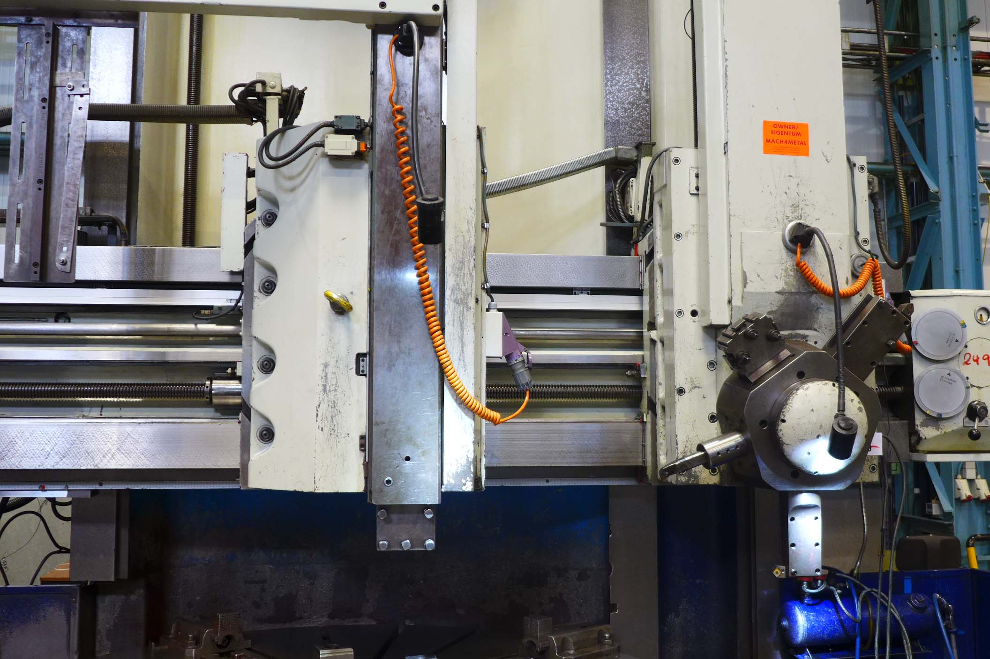
- Cutting force : 6.000 Kp

- Dimensions
- Length : 3.700
- Width : 4.700
- Height : 4.300
- Weight : 30.000

- incl. digital read out
- incl. conical turning
- incl. tread cutting
- incl. V Constante

Please Note: The above information has been obtained to the best of our ability and belief from, and from the manufacturers where possible. It is given in good faith, but its accuracy can not be guaranteed. Accordingly, it will not form a representation or constitute contractual terms. We advise you to check any vital details

